alumni News
A Monthly newsletter brought to you by Mercy College of Ohio

JOIN US FOR VIRTUAL AND IN-PERSON EVENTS!

MOVIES FOR MENTAL HEALTH

On Wednesday, February 16 from 6:00 pm to 8:00 pm EST join Mercy College and Art with Impact for “Movies for Mental Health.” This virtual workshop uses the power of film to unite folks in the community with connection and conversation. RSVP for Movies for Mental Health. This interactive, online experience will feature an anonymous, chat-based discussion on mental health, the stigma that frequently surrounds mental illness, and media portrayals of mental health issues. There will be a live screening of three award-winning short films, therapeutic activities to consciously connect minds and bodies, and a collective exploration around what the work means for us as individuals.

Mercy College provides free and confidential mental health counseling appointments and a relaxation & sensory room for current students. Learn more about counseling and wellness services through our virtual tour.

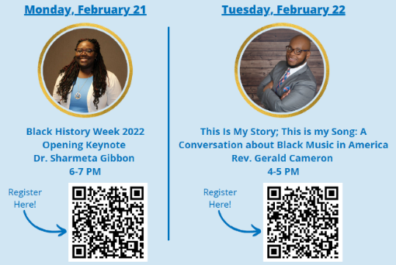
BLACK HISTORY WEEK SPEAKERS

On Monday, February 21 at 6:00 pm, Dr. Sharmeta Gibbon will be providing a Black History Week Opening Keynote. Dr. Gibbon is a proud member of the Toledo community. She is a product of the Toledo Public School system, she graduated with her BSN from Bowling Green State University, and she later attended the University of Toledo where she completed her MSN. Dr. Gibbon worked as a RN for several years specializing in Adult Medical Surgical Care. She began her teaching career at Mercy College of Ohio in the BSN program. After teaching for several years, she earned her doctorate in higher education at Walden University and completed her program in Fall 2020. Dr. Gibbon recently accepted a teaching position at the University of Toledo in the College of Nursing. This position has allowed her to grow and develop professionally. In addition to teaching in the undergraduate program she now serves as the Diversity, Equity, and Inclusion (DEI) Officer for the College of Nursing. Dr. Gibbon also serves as a member of the faculty Diversity and Inclusion committee where she collaborates with faculty to increase awareness about diversity issues in health care. RSVP for Opening Keynote.

On Tuesday, February 22 from 4:00 pm to 5:00 pm, Reverend Gerald Cameron will be sharing “This is My Story; This is My Song: A Conversation about Black Music in America.” Reverend Cameron is the Director of Spiritual and Community Engagement at Mercy College of Ohio. Participants are encouraged to attend online and experience the richness of Black History Month through the lens of Black Music in America. From spiritual hymns, to R&B, to Hip-Hop, to Rock and Roll, Black Music is one of the world’s greatest artforms that illustrates the pains and the triumphs of a society. RSVP for A Conversation About Black Music in America.
ALUMNI JOB OPPORTUNITIES

Interested in learning about job opportunities in your field? Make sure that the Mercy College Office of Career and Professional Development has your updated contact information on file!
The mission of the Office of Career and Professional Development is to inspire, challenge, and empower students and alumni as they transform into servant leaders in the global community by offering programs, services, and resources that focus on career and professional development and lifelong learning.
Update your information here or by scanning the QR code to the left.
Those with questions or interest in learning more should contact Kristen.Porter1@mercycollege.edu
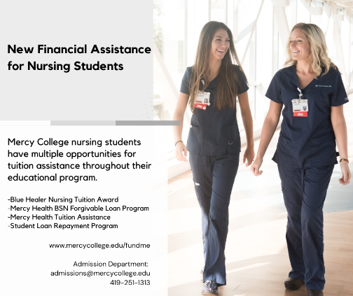
NEW FINANCIAL ASSISTANCE FOR NURSING STUDENTS

Mercy College nursing students have multiple opportunities for tuition assistance throughout their educational program, including tuition awards, loan forgiveness, and tuition assistance.

Blue Healer Nursing Tuition Award: All new nursing students (ASN, BSN, or Accelerated BSN) are awarded a $2,000 tuition award in their first semester (summer or fall 2022).
Mercy Health BSN Forgivable Loan Program: Direct from high school students enrolled in the BSN Prelicensure program are eligible for student loan forgiveness if they obtain their RN licensure, become successfully employed by Mercy Health in the greater Toledo market, and remain employed for 48 months.
Mercy Health Tuition Assistance: Students who are Mercy Health associates employed PRN, part-time, or full-time and work at least six (6) hours per week are eligible for full tuition assistance, standard tuition assistance, and/or tuition reimbursement plans depending on their program of study.
Student Loan Repayment Program: Full or part-time Mercy Health associates are eligible for repayment of federal student loans after graduation if they sign up with Benefit Ed. Monthly payments increase over time and are paid directly to the associate’s student loan service provider.
Learn more online or by contacting Admissions at admissions@mercycollege.edu or 419-251-1313.
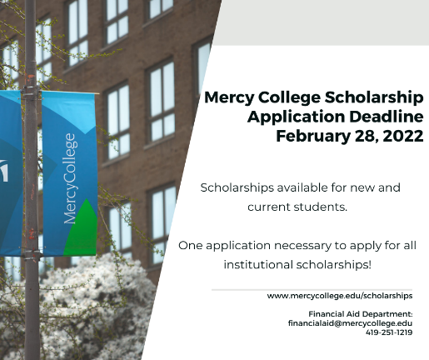
SCHOLARSHIPS

Mercy College’s scholarship application deadline is February 28! Scholarships are available for new and current students. Only one application is necessary for all Mercy institutional scholarships.
Apply now! Those with questions can contact the Financial Aid Office at financialaid@mercycollege.edu or the Admissions Office at admissions@mercycollege.edu / 419-251-1313.
Mercy College offers many pathways to begin and advance your career in healthcare.
FACULTY SPOTLIGHTS

Dr. Padmaja Nandigama (pictured left-top), Assistant Professor of General Education at Mercy College, presented at the international Student Wellness and Leadership Conference. The presentation focused on how to overcome the fear that other people are doing better or leading better lives.

Dr. Sung-David Chun (pictured left-middle), Professor of General Education at Mercy College, presented at the 2021 Annual Meeting of the American Sociological Association. The presentation focused on wage disparities among Registered Nurses in the United States.

Dawn Borgerson (pictured left-bottom), Assistant Professor and Nursing Simulation/IPE Coordinator at Mercy College, earned a certification from the International Nursing Association for Clinical Simulation and Learning. This training focused on learning best practices for advancing the science of simulation, facilitating learner-centered simulations, and generating evaluations which focused on the patient, healthcare worker, and the healthcare system.

Mercy College of Ohio provides Education for Life. We’re proud of the ambitions and accomplishments of students, alumni, faculty, staff, and friends of the College. Each month, current students and/or alumni will be recognized. Tell us your Mercy story. Please email suggested names to Alumni@mercycollege.edu or complete a nomination form here.

Peer-nominations and self-nominations are accepted.
The Mercy College of Ohio Alumni Department is committed and focused on providing Mercy alumni an experience that is informative, engaging, and fun! We're there for you whether you're enjoying one of our alumni events or supporting Mercy as a volunteer.
Your Alumni Department goes the extra mile to keep you informed.

Your Mercy Pride is ours as well – To ensure this newsletter is as informational as possible, please send your comments and article submissions to:

Mercy College of Ohio
Attn: Alumni Department
2221 Madison Ave.
Toledo, OH 43604
alumni@mercycollege.edu | 419-251-8993 (alum)

Facebook

Instagram

Twitter

